**Germany Smart Medical Devices Market**

According to Intelli, the Germany Smart Medical Devices Market was valued at approximately USD 11,646.60 million in 2024 and is projected to reach USD 31179.67 million, growing at a compound annual growth rate (CAGR) of 14% during the forecast period of 2024 to 2032.

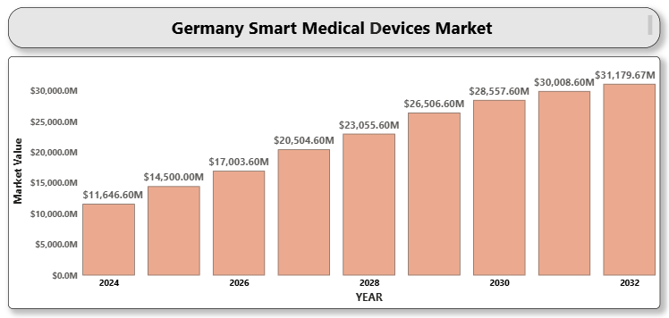

**Germany Smart Medical Devices Market Definition**

Smart medical devices are technologically advanced instruments embedded with sensors and software that can collect, transmit, and analyze health data. These devices aid in continuous monitoring, early diagnosis, and treatment adherence, improving clinical outcomes and patient engagement. With the integration of the Internet of Things (IoT), machine learning, and data analytics, smart devices are reshaping healthcare delivery models in Germany.

**Germany Smart Medical Devices Market Overview**

Germany is experiencing a significant transformation in its healthcare sector with the adoption of smart medical devices. Increasing demand for personalized care, rising health consciousness, and growing infrastructure for digital health platforms are driving the market. Government initiatives supporting telemedicine and eHealth, along with reimbursement support for connected devices, are further boosting adoption across healthcare settings.

**Germany Smart Medical Devices Market Segmentation Analysis**

### By Product Type

* **Diagnostics & Monitoring Devices**: Includes blood glucose monitors, cardiac monitors, and wearable sensors.
* **Therapeutic Devices**: Encompasses insulin pumps, pain management devices, and respiratory therapy devices.​

### A close-up of hands holding a tablet and a pen Description automatically generated1.2 By Type

* **A close-up of hands holding a tablet and a pen

  Description automatically generatedOn-body (Adhesive Patch)**
* **Off-body (Belt Clip)**
* **Handheld Devices**​

### 1.3 By Technology

* **Spring-based**
* **Motor-driven**
* **Rotatory Pump**
* **Expanding Battery**
* **Pressurized Gas**
* **Others**​

### 1.4 By Modality

* **Wearable Devices**: Such as fitness trackers and smartwatches.
* **Non-wearable Devices**: Including smart inhalers and connected imaging devices.

### 1.5 By Application

* **Oncology**
* **A close-up of hands holding a tablet and a pen

  Description automatically generatedDiabetes Management**
* **Autoimmune Disorders**
* **Infectious Diseases**
* **Sports and Fitness**
* **Sleep Disorders**
* **Others**​

### 1.6 By End User

* **Hospitals**
* **Clinics**
* **Home Care Settings**
* **Sports Clubs**
* **Others**​

### 1.7 By Distribution Channel

* **Pharmacies**
* **Online Channels**
* **Others**

**Key Players**

Prominent companies operating in the Germany Smart Medical Devices Market include:

* Medtronic
* Philips Healthcare
* Abbott Laboratories
* Dexcom Inc.
* GE Healthcare These companies are innovating in wearable sensors, cloud-based diagnostics, and AI-enabled analytics. Strategic collaborations with hospitals and startups are further driving product innovation.

**Key Developments**

* Medtronic expanded its AI-based remote monitoring portfolio for diabetic care in Germany.
* Philips partnered with a German university hospital to pilot smart ICU devices.
* Abbott launched an advanced version of its wearable glucose monitor for the German market.
* Dexcom opened a new R&D hub in Germany focused on next-gen biosensor technology.

**Market Attractiveness**

advanced healthcare infrastructure, robust data privacy laws, and strong R&D ecosystem. Supportive digital health policies, combined with a growing aging population and a tech-savvy younger demographic, make Germany a high-potential growth region.

**Porter’s Five Forces**

* **Threat of New Entrants**: Moderate. Although regulatory hurdles and the need for high technological capability pose entry barriers, innovation-driven startups still find opportunities.
* **Bargaining Power of Suppliers**: Moderate. Suppliers of sensors and AI software components have power due to innovation needs, but the presence of multiple vendors reduces dependency.
* **Bargaining Power of Buyers**: High. With access to multiple brands and growing cost sensitivity, buyers influence product pricing and feature offerings.
* **Threat of Substitutes**: Low. The specialized nature and evolving capabilities of smart medical devices limit substitutes.
* **Industry Rivalry**: High. Intense competition from multinational and domestic players drives continuous innovation, pricing pressure, and R&D investment.

1. **INTRODUCTION OF GERMANY SMART MEDICAL DEVICES MARKET**

1.1 Overview of the Market

1.2 Scope of Report

1.3 Assumptions

1. **EXECUTIVE SUMMARY**
2. **RESEARCH METHODOLOGY**

3.1 Data Mining

3.2 Validation

3.3 Primary Interviews

List of Data Sources

1. **GERMANY SMART MEDICAL DEVICES MARKET OUTLOOK**

4.1 Overview

4.2 Market Dynamics

4.3 Drivers

4.4 Restraints

4.5 Opportunities

4.6 Trends

4.7 Porters Five Force Model

4.8 Value Chain Analysis

1. **GERMANY SMART MEDICAL DEVICES MARKET, BY PRODUCT TYPE**

5.1 Diagnostic and Monitoring Devices

5.2 Therapeutic Devices

5.3 Wearables

1. **GERMANY SMART MEDICAL DEVICES MARKET, BY APPLICATION**

6.1 Chronic Disease Management

6.2 Remote Patient Monitoring

6.3 Preventive Health & Wellness

6.4 Others

1. **GERMANY SMART MEDICAL DEVICES MARKET, BY END-USER**

7.2 Ambulatory Surgical Centers

7.3 Homecare Settings

7.4 Others

1. **GERMANY SMART MEDICAL DEVICES MARKET COMPETITIVE LANDSCAPE**

8.1 Company Market Ranking

8.2 Key Development Strategies

1. **COMPANY PROFILES**

**9.1 Medtronic**

9.1.1 Overview

9.1.2 Financial Performance

9.1.3 Product Outlook

9.1.4 Key Developments

**9.2 Philips Healthcare**

9.2.1 Overview

9.2.2 Financial Performance

9.2.3 Product Outlook

9.2.4 Key Developments

**9.3 Abbott Laboratories**

9.3.1 Overview

9.3.2 Financial Performance

9.3.3 Product Outlook

9.3.4 Key Developments

**9.4 Dexcom Inc.**

9.4.1 Overview

9.4.2 Financial Performance

9.4.3 Product Outlook

9.4.4 Key Developments

9.5 GE Healthcare

9.5.1 Overview

9.5.2 Financial Performance

9.5.3 Product Outlook

9.5.4 Key Developments

1. **KEY DEVELOPMENTS**

10.1 Product Launches/Developments

10.2 Mergers and Acquisitions

10.3 Business Expansions

10.4 Partnerships and Collaborations

1. **APPENDIX**

11.1 Related Research